JS Lecture1

Everything inside JS happens inside an Execution Context. The global Execution context os created inside the **Call Stack**.

Its like a big container containing 2 componets:

1 Memory Component: In which all the values are stored as key value pairs. It is also known as Variable Environment. It stores all the variables and function.

2 Code Component: (Thread of Execution) : Herein all the code is executed one line at a time.

**JS is a synchronous single threaded language.**

**Single Threaded:** Can execute a single command at a time in a specific order. Means only after first line has completed its execution I can go to the next line. Which means Synchronous.

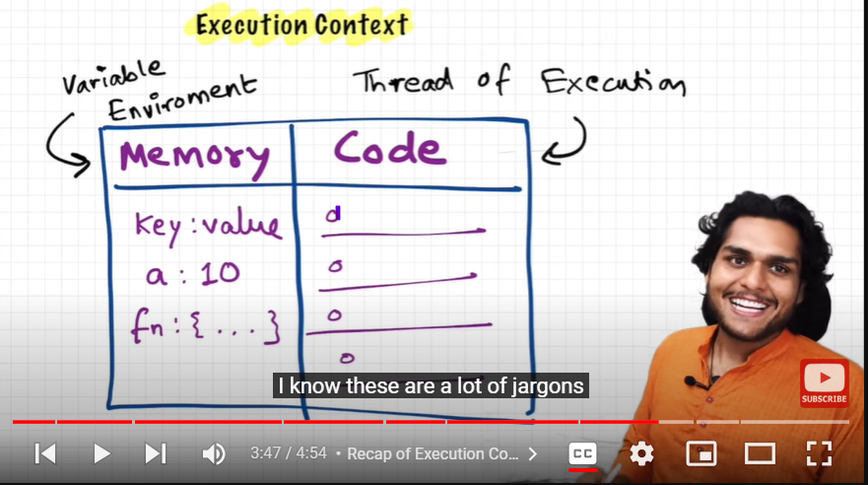  
What happens after running JS Code?  
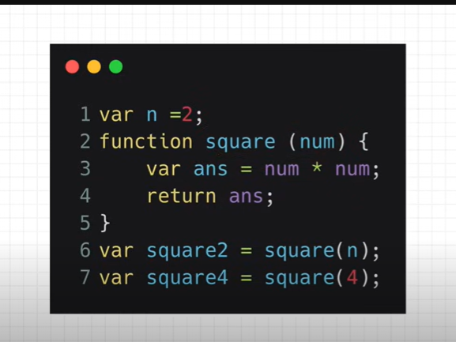

EC(Execution Context) takes place in 2 phases: 1 Memeory Creation Phase 2 Code execution phase

1 In first phase JS allocates memory to variables and functions. In forst phase ot allocates undefined value to all variables and stores the whole code of functions in memory state. Blow image shows phase 1

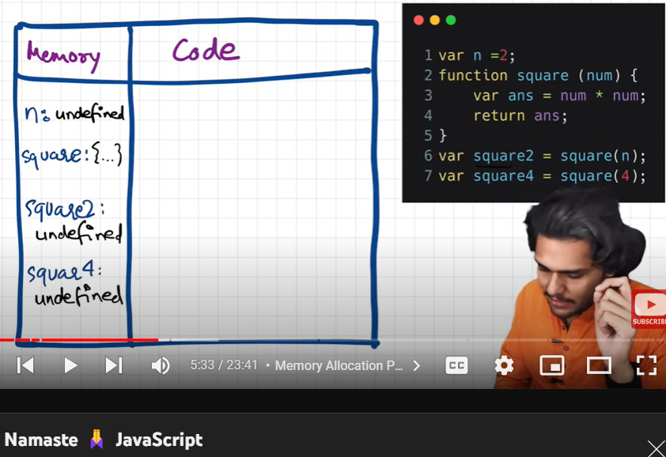

2 In the code execution phase, JS runs the code line by line. And here it actually allocates the values to variables. Now according to code, it allocates value 2 to variable n instead of undefined. Now, it doesn’t go inside function so it directly jumps to line number 6 and executes the function when function is called. So, at line number 6 its called and hence it creates a new EC for the function. And here again 2 phases will be involved.

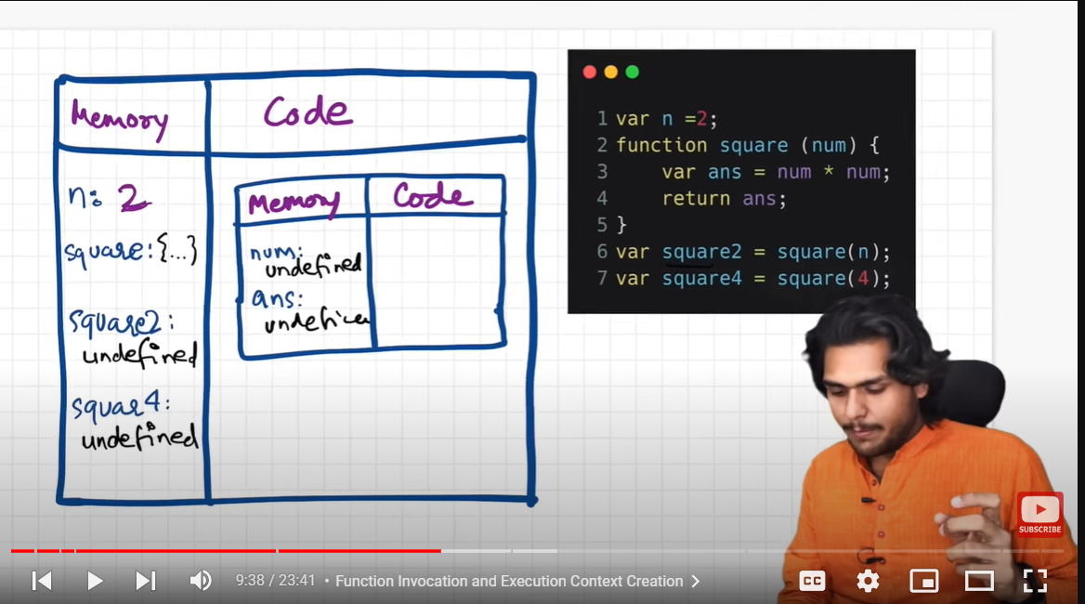

In that EC, in first phase, num will be given a value of undefined and ans will be given value of undefined as well.

In the next code execution phase, we will pass the value of n that os 2 to the function. That is parameter n is 2 and its value will be passed to function argument num .So its shown in diagram below.

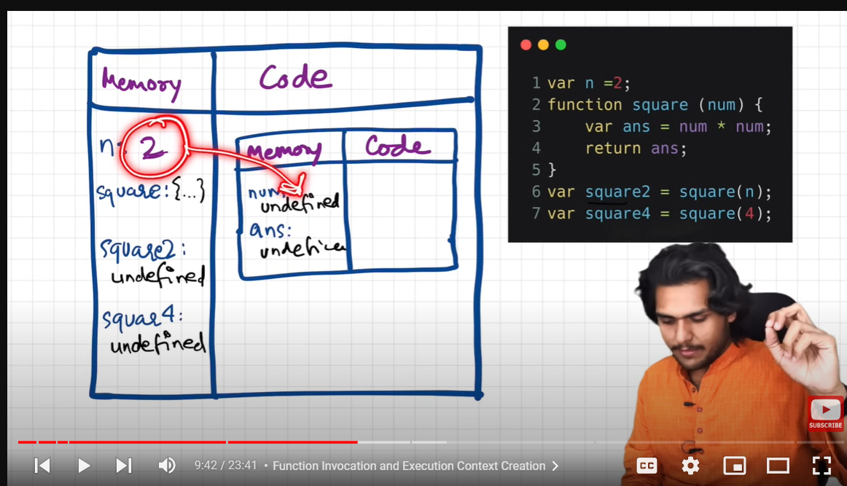

Futher more in the code execution phase, in line number 3, code block will execute the value of num*num and will give that value to ans instead of undefined.

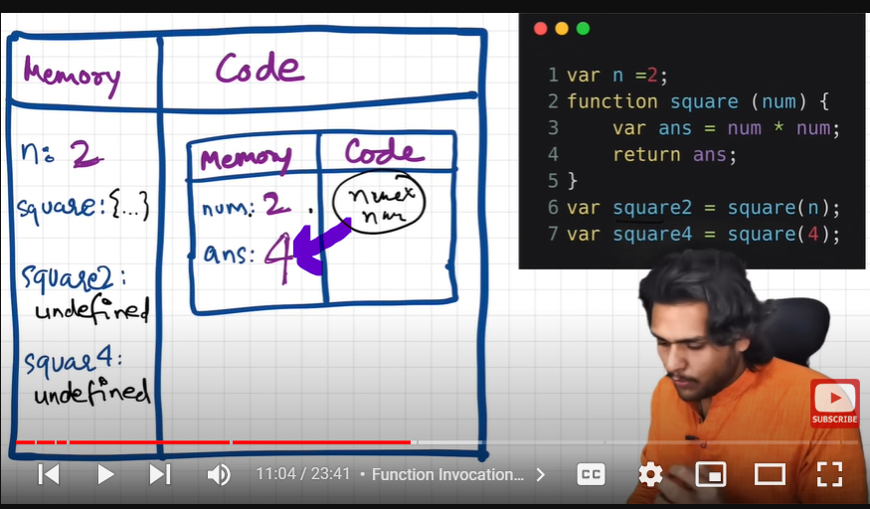

After finishing line number 3 control goes to line number 4 ans we encounter return keyword. It says that return the value of ans to the place where the function was iinvoked means at line number 6 . So in code section, the value of ans it will find on local memory.

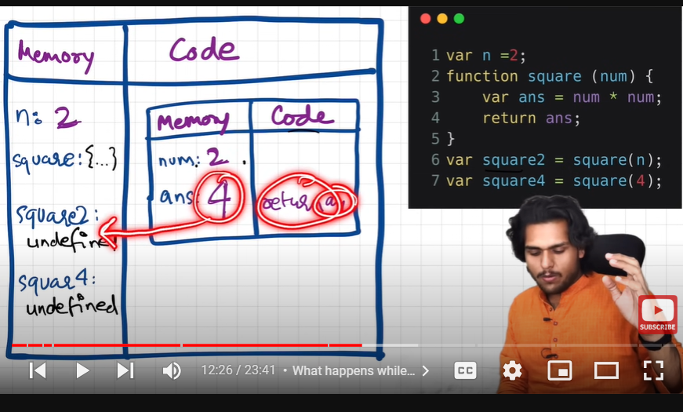

So square2 will be allocated the value of 4.

Now, most important thing, the execution context created for this function will be deleted from the code part soon after its execution .

So, now the control goes to line number 7.

Again new EC is created. It will again go through 2 phases.

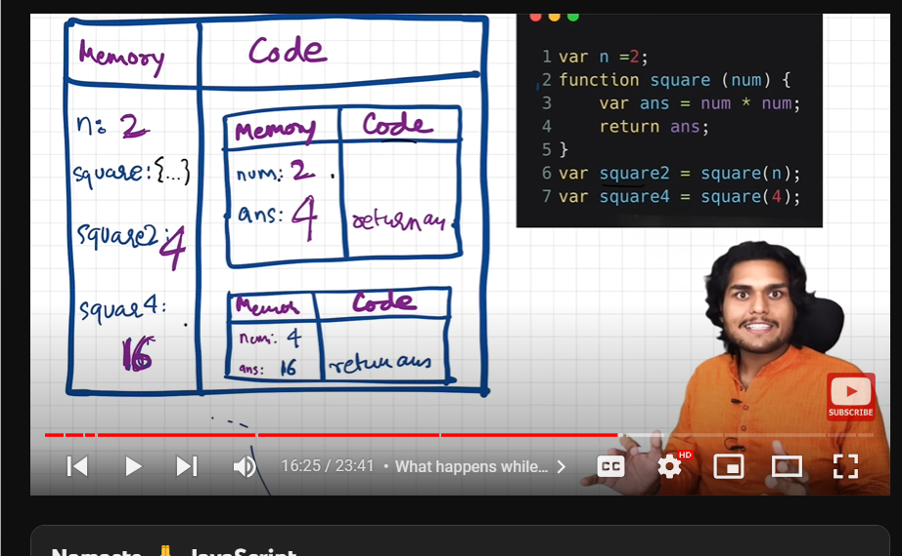

After all execution is done, the Global execution context is also deleted.

**Hoisting in JS**

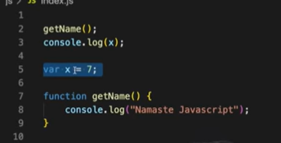 **Output:** Namaste Javascript

Undefined

But if we remove line number 2 it will give next output as not defined.

This thing of accessing variables without even declaring it is knows as Hoisting in JS.

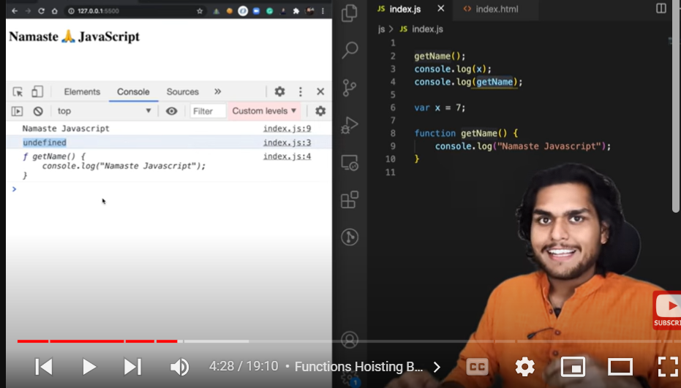

So, in case of variable, it gives undefined but In case of function, it prints the function. So as we know, when getname() is called it goes to where the function is defined and executes that code. As we can see that code makes a new execution context and gives me output Namaste JS, I will get the output as Namaste Javascript.

But , Note **If a function defined is an arrow function then it behaves just like a variable and will give the output undefined if its sais to be printed even before intialising it.** Even when function is written in the following way, it behaves just like a variable.

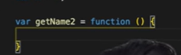

Now, as in call stack we know EC gets created. So whenever a new function is invoked a new EC is created on top of the Global EC in the call stack with the name of function. It is popped out as well whenever the function execution gets completed.

**How Functions work behind the scenes?**

**Output:** 10,100,1

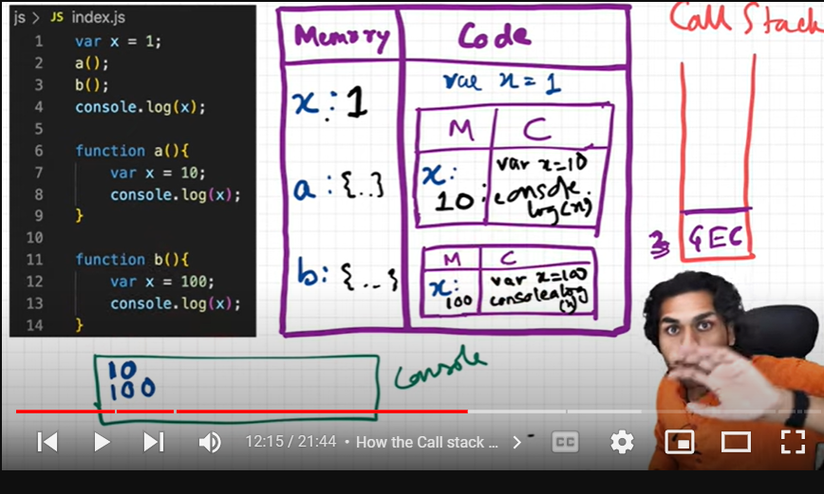

**Whenever** we run JS, just like Global EC, A Global object is created. Now, when we run JS, global object named as **this** is created. So, even the file is empty, a global object is created. In case of browser**, this ===window**. So, an object named as window is created.

**Global Space:**

**Everything written outside functions are in global space.**

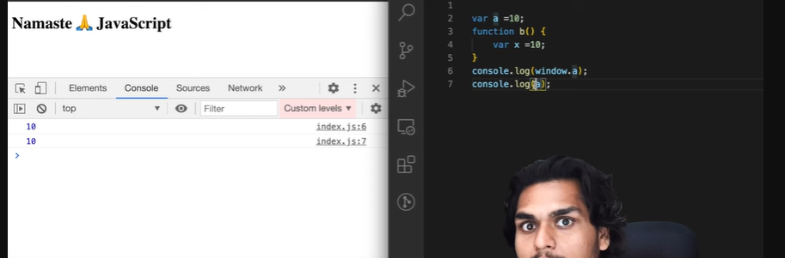

Whenever we try to access any variable in the program even without using window.variable_name, it assumes the variable present n the global space and gives an output regarding the same. Even if you write comsole.log(this.a) it will give the same output. So shortest program in JS is the program without any code.

**Undefined Vs Not Defined**

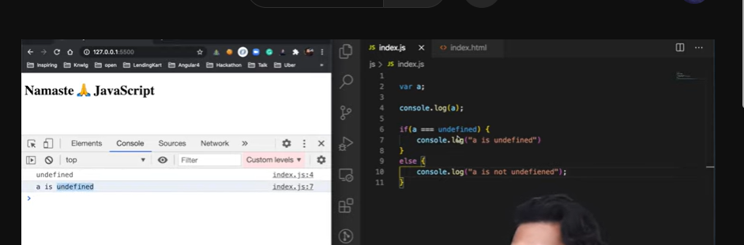

Whenever we make a variable, Js gives it a placeholder named as undefined. And in the later phase, if it gets the value then it isn’t undefined as can be seen below.



**Loosely/Weakely Typed Language**

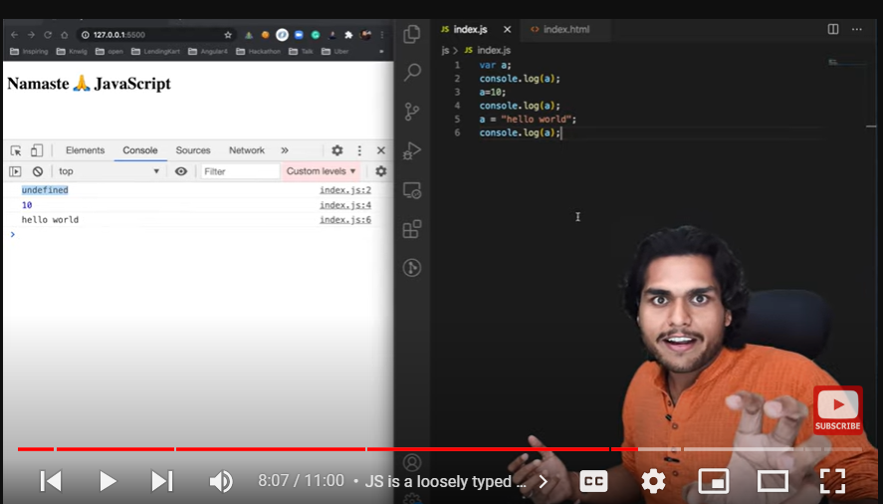

Means once the variable is initialised, we can even change its values.

**Scope:**

Means where can we access the given variable. Or to check if the variable comes inside the given functions scope.

**Lexical Environment: (LE)**

Whenever a global EC Is created, a Lexical Environment is also created along with it. LE is the local memory along with Lexical Environment of its parent. Which means the below function c() is sitting Lexically inside function a(). And a() is lexically inside Global Scope.

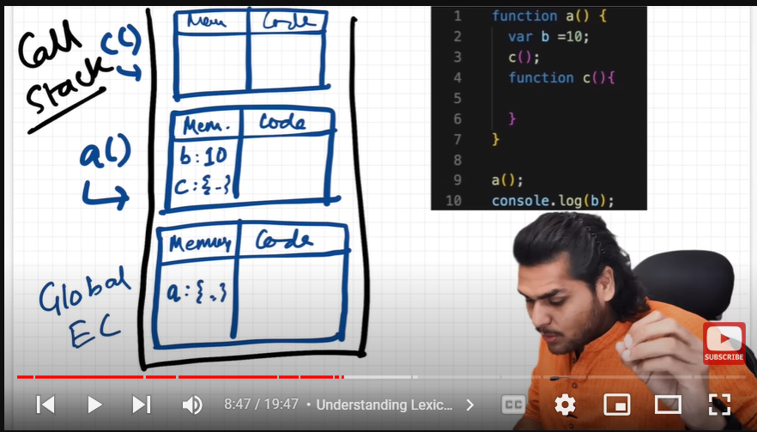

The reason a global variable is accessible inside functions when its declared before them is because the function contains its memory along ith the Lexical Environment of its parent. So if some variable its unable to find in its memory it can assess its parents memory as we..

So, c points to a’s memory which in turn point s ot the global memory which points to NULL As Global doenst have parent . This way of finding variable in parent’s memory and then ots parent’s memory is known as **Scope Chain.**

**Let and Const: Introduced in ES6**

**Let and const declarations are hoisted but in a different manner. They are In the temporal dead zone.**

Just as var, let and const are also assigned memory bit instead of assigning memory in gloabal space , they are assigned memory elsewhere only and that memory space can only be accessed onc you have given them some value.

The time since when let variable os hoited and value os actually assignmed to that is known as **Temporal Dead Zone.** So, when you try to access a variable inside Temporal dead zone, it gives a **Reference Error**.



We can also get Reference error if we try to access some variable that wasn’t present in our JS code. But here along with error, messege is different.

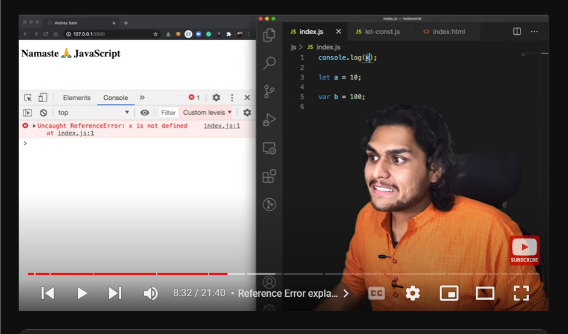

These let and const variables aren’t attached to window object as var are as they are stored in a separate memory space. And hence is the difference between the below outputs for let and var.



In Let, I am unable to Redeclaration means I cannot declare a variable with same name. But if I try to do it, it will give me a **Syntax Error** as below:



So in case of this, JS wont run a single line of code. So I cannot use the same name in the same scope again.

**Const:**

In case of let, we can declare it and then assign it with some value later. Means

Let a;

a = 100 is completely fine.

But, **const has to be declared and initialised at the same time.**

Else is gives us s Syntax Error.

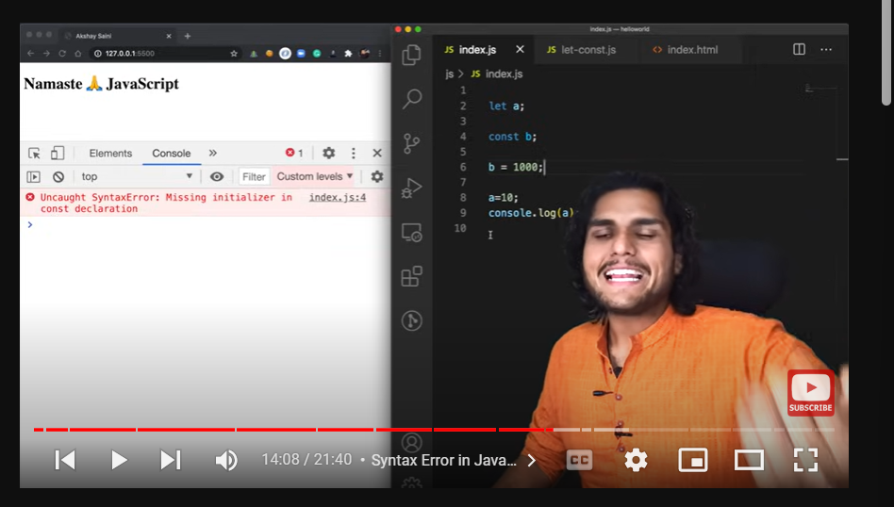

Now, if we try to give some different value to const variable it gives us a **TypeError** as follows:

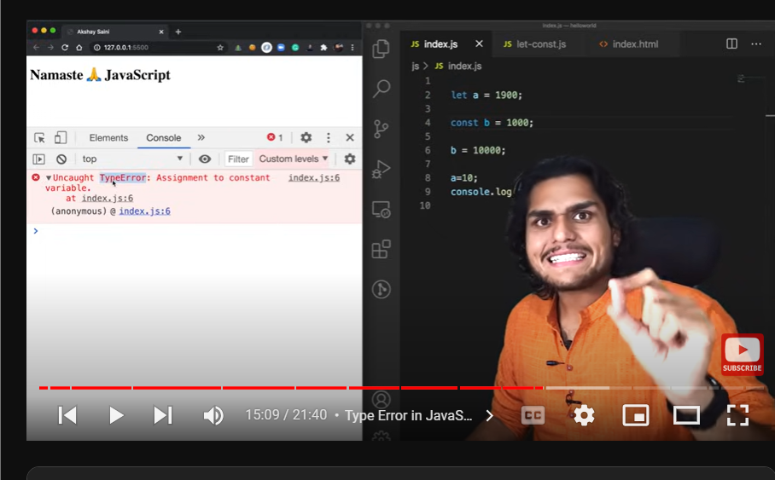

**Let and const are Block Scoped:**

**Block:**

Used to combine multiple JS Statements into one group. So we can group multiple statements in a block and use it whenever a JS expects only one statement.

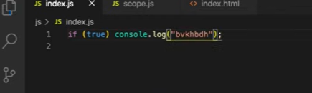

For Eg: If expects a single statement after it as given here console.log() or any other single statement like true; but if we want to use a block of statements, we can group them together and use them instead of a singe statement as mentioned below.

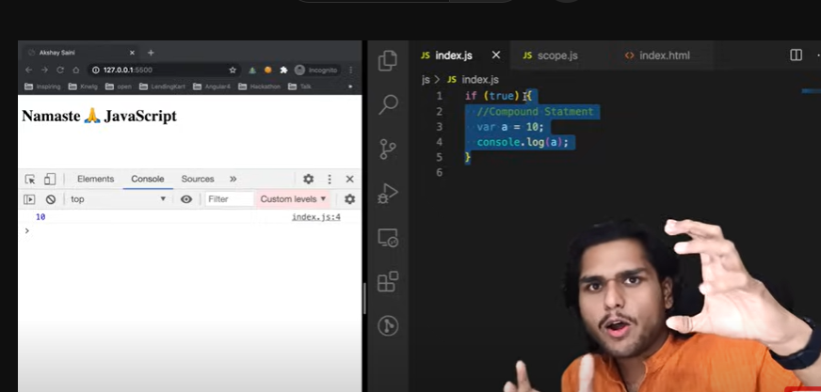

**Block Scope:**

What all variables and functions can be accessed inside a block is known as Block scope.

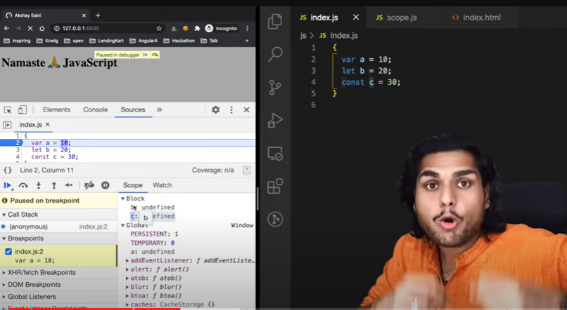

So as we can see b and c variables that is let and const variables come inside the block scope they are histed but just assigned a different memory space names as block here. And var a is hoisted inside the global scope.

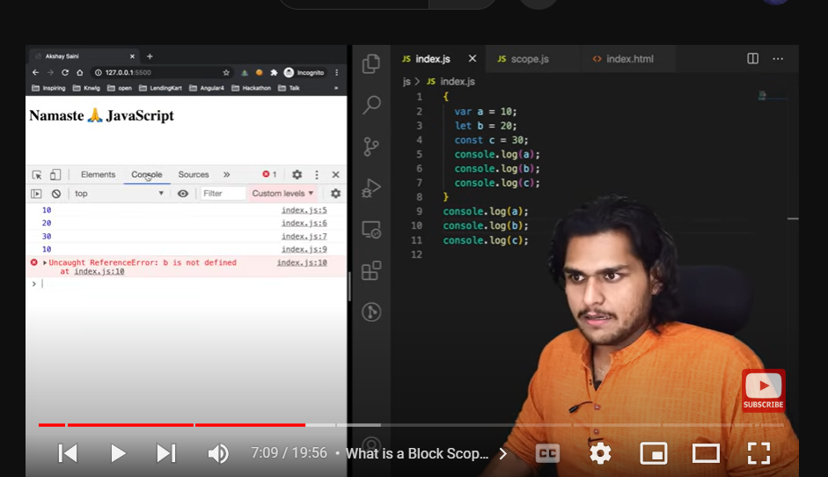

**Shadowing:**



**As you can see, vr a=10 shadows var a =100.** This is known as shadowing.

Interesting:

Even if we try to access it outside block it still gives the modifies output.



Means. Var a=10 ,modified the value if var a=100 as both a are pointing to the same memory location.

But, case is different in case of let.

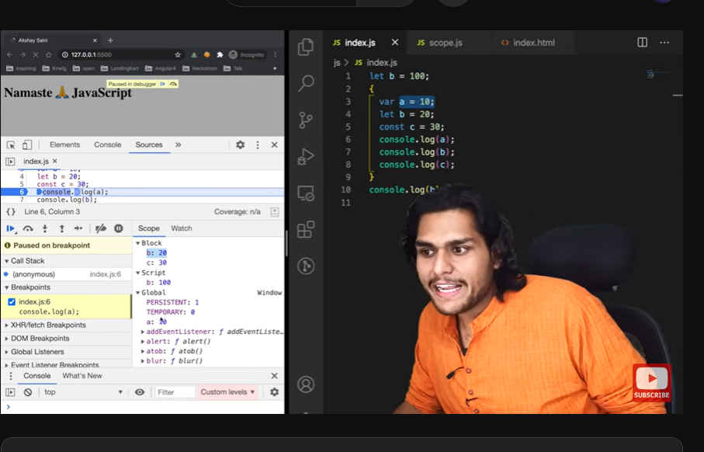

Output: 10 20 30 100

In case of const, 

Shadowing one more example:

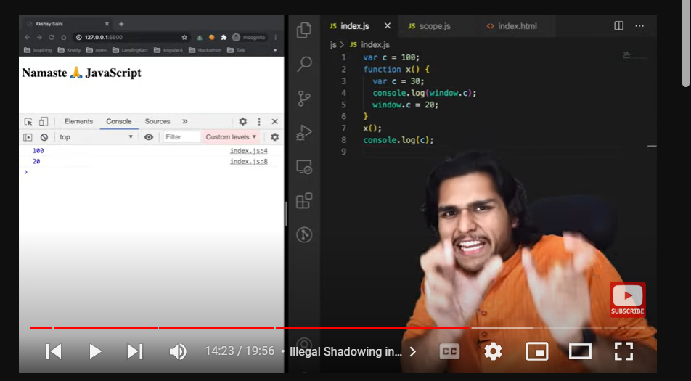

**Illegal Shadowing:**



But this is valid:

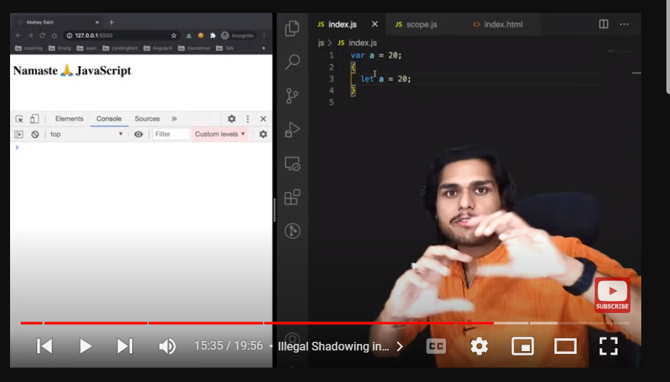

So, we can shadow let with var but cannot shadow var with let.

This is because while shadowing var cannot coss its boundries. We know var os function scoped. So this is valid:

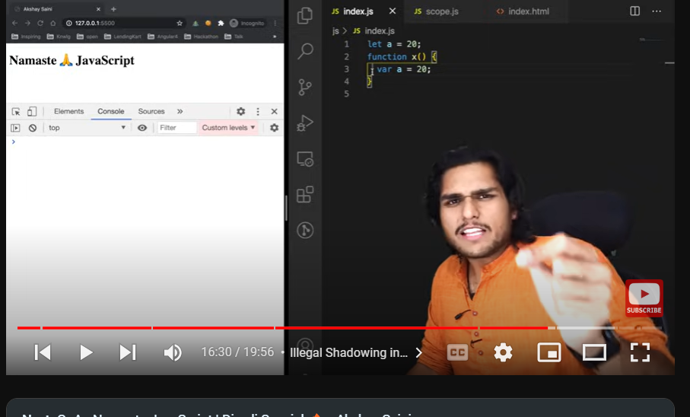

As here, var isn’t crossing its boundaries.

These block also follow lexical scope.

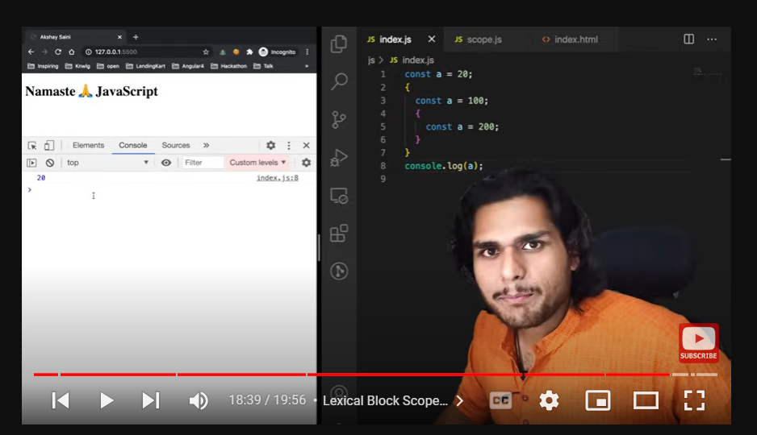

But, if we do console.log(a) after a=200, it will give me an error.

**Function declared in any way like arrow functions or normal functions f variable- then function declarations, all have the same scope rules.**

**Closures:**

Function along with its lexical scope is known as Closure.